|  |
| --- |
| **C:\Users\faisal\Pictures\NSU_pic_download\n91267046457_2661.jpg**  **CSE 311L(Database Management System)**  **LAB-Week 05 (Part A)** |

**Subqueries**

Topics:

* Using a Subquery to Solve a Problem
* Subquery Syntax
* Single-Row Subqueries
* Executing Single-Row Subqueries
* Using Group Functions in a Subquery

**Who has a salary greater than Abel’s?**

**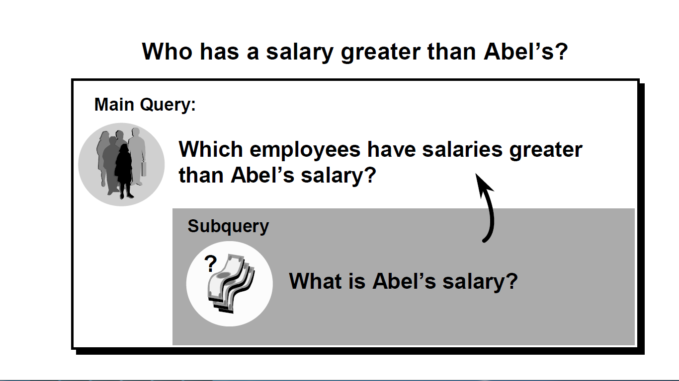**

**Using a Subquery**

SELECT last\_name

FROM emps

WHERE salary >(SELECT salary

FROM emps

WHERE last\_name = ’Abel’);



**Single-Row Subqueries**

* Return only one row
* Use single-row comparison operators

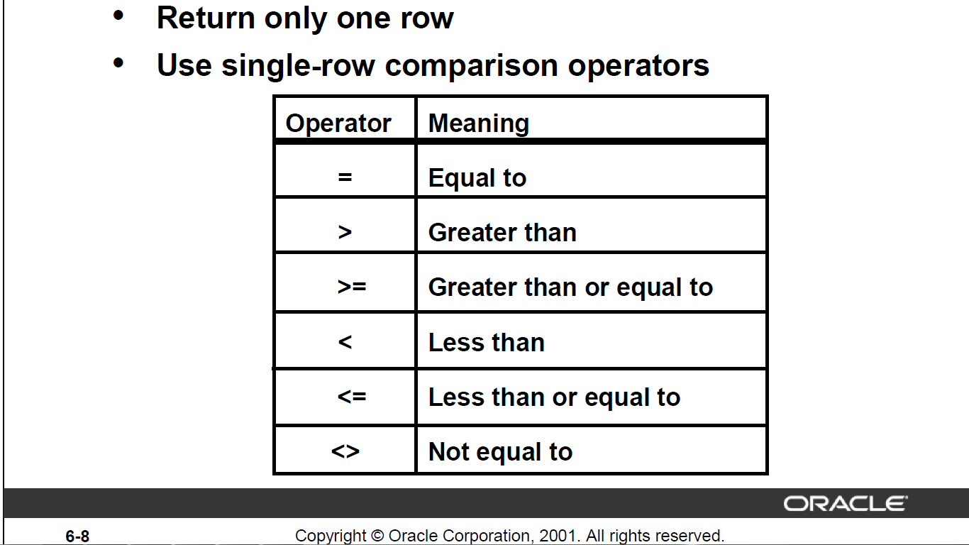

**Executing Single-Row Subqueries**

SELECT last\_name, job\_id, salary

FROM emps

WHERE job\_id =

(SELECT job\_id

FROM emps

WHERE employee\_id = 141)

AND salary >

(SELECT salary

FROM emps

WHERE employee\_id = 143);

****

**Using Group Functions in a Subquery**

SELECT last\_name, job\_id, salary

FROM emps

WHERE salary =

(SELECT MIN(salary)

FROM emps);



**Activity 01:**

Write a query to display the last name and hire date of any employee in the same

department as Zlotkey. Exclude Zlotkey.



**Activity 02:**

Create a query to display the employee numbers and last names of all employees who earn more

than the average salary. Sort the results in ascending order of salary.

.



**Subqueries**

Topics:

* Single-row operator with multiple-row subquery
* Multiple-Row Subqueries
* Using the ANY Operator
* Using the ALL Operator

**Multiple-Row Subqueries**

* Return more than one row
* Use multiple-row comparison operators

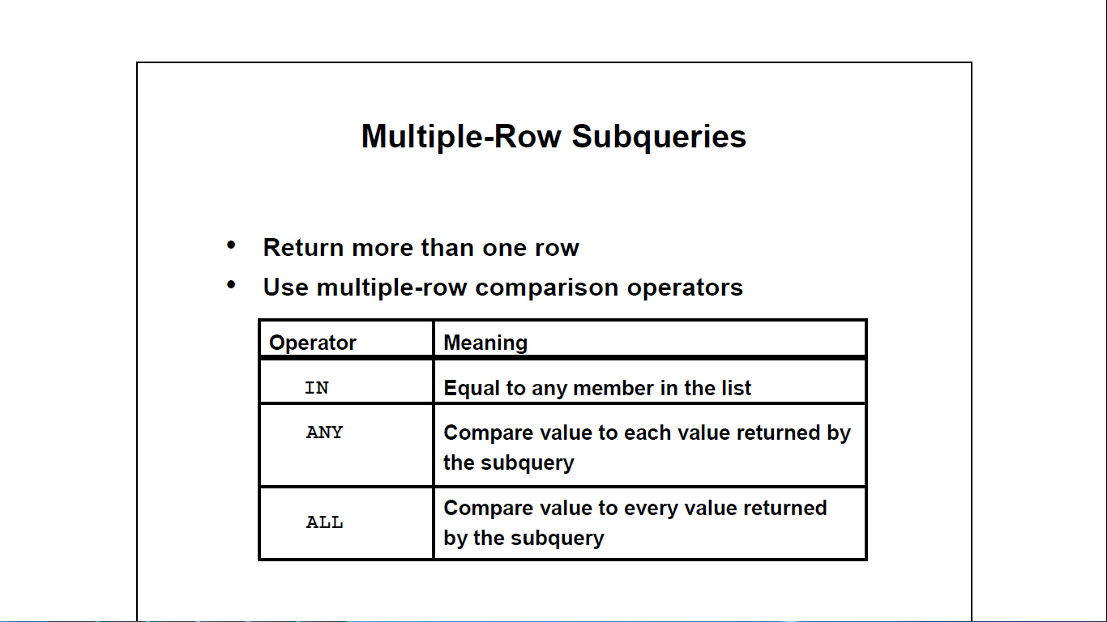

**Using the ANY Operator**

SELECT employee\_id, last\_name, job\_id, salary

FROM emps

WHERE salary < ANY

(SELECT salary

FROM emps

WHERE job\_id = ’IT\_PROG’)

AND job\_id <> ’IT\_PROG’;



**Using the ALL Operator**

SELECT employee\_id, last\_name, job\_id, salary

FROM emps

WHERE salary < ALL

(SELECT salary

FROM emps

WHERE job\_id = ’IT\_PROG’)

AND job\_id <> ’IT\_PROG’;



**Activity 01:**

Display the last name and salary of every employee who reports to King.



**Activity 02:**

Write a query to display the employee numbers, last names, and salaries of all employees who earn more than the average salary and who work in a department with any employee with a *u* in their name.

